Shubham Santosh Katore

AI/ML Researcher | Healthcare AI & Medical Imaging
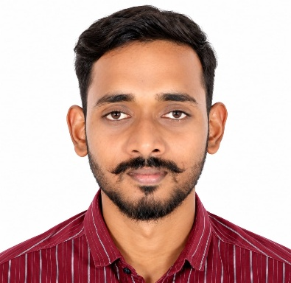

Profile
Shubham Santosh Katore is an accomplished healthcare AI and machine learning professional with a strong academic foundation in Medical Imaging Technology, Health Informatics, and Analytics. His journey reflects the powerful combination of healthcare knowledge, advanced technology, and research-driven innovation.
He completed his M.Sc. in Health Informatics & Analytics from The Apollo University, graduating with an outstanding CGPA of 9.75/10.0. During his academic journey, he developed a strong interest in artificial intelligence, deep learning, medical imaging, and clinical applications of technology.
Today, Shubham serves as a Junior Research Fellow (AI/ML) at the Advanced Centre for Treatment, Research and Education in Cancer (ACTREC), Tata Memorial Centre, where he works on AI-driven solutions for medical and cancer research.

Academic Journey
- M.Sc. Health Informatics & Analytics
The Apollo University, Chittoor
CGPA: 9.75/10.0 | 2024–2026
- B.Sc. Medical Imaging Technology
Tata Institute of Social Sciences (TISS), Mumbai
GPA: 7.7/10.0 | 2021–2024
His postgraduate academic work focused on machine learning, deep learning, data pipelines, model deployment, and cloud computing, along with research on the evolution from CNN architectures to Vision Transformers for clinical deployment.

Professional Journey
Shubham began building his healthcare expertise through medical imaging and later expanded into artificial intelligence and machine learning.
As a Radiology Technician at Saint George Hospital, Mumbai, he gained practical exposure to CT, MRI, and X-ray imaging and developed an understanding of healthcare imaging systems such as DICOM, PACS, and RIS.
He subsequently moved into AI research at ACTREC, Tata Memorial Centre, where he worked on deep learning and medical imaging applications. He currently serves as a Junior Research Fellow (AI/ML), contributing to AI-assisted cancer research and clinical applications.

Research & Innovation
One of Shubham's notable contributions is the development of an automated karyotyping platform using YOLOv8 and Swin Transformer. The system automates chromosome detection, classification, and karyotype generation from microscopy images and has been deployed for clinical laboratory use.
The system achieved:
- 92% classification accuracy
- 40% reduction in cytogenetic analysis time
- 3× faster sample processing
- 60% reduction in manual annotation effort
The platform combines artificial intelligence with clinical cytogenetics to support faster and more efficient laboratory workflows.

Other Notable Projects
Shubham has also worked on several healthcare-focused AI projects:
Malaria Cell Classification
Developed a deep learning system that achieved 94% accuracy on 27,558 blood smear images, with explainable AI using Grad-CAM and a deployed Flask-based application.
COPD Risk Prediction
Developed a machine learning model achieving 92% accuracy and an AUC of 0.89, along with an NLP-based clinical chatbot designed to support healthcare documentation.
Healthcare Data Pipeline
Designed an EHR/FHIR-based data pipeline that enabled 5× faster queries for machine learning feature engineering and reduced data quality issues by 85% through automated validation.

Areas of Expertise
- Healthcare Artificial Intelligence
- Machine Learning & Deep Learning
- Medical Image Analysis
- Computer Vision
- Medical Imaging
- Clinical Data Analytics
- Bioinformatics & Healthcare Data
- Natural Language Processing
- Model Deployment and MLOps
- Healthcare Information Systems

Professional Certifications
- AI in Healthcare Specialization – Stanford Online, Coursera
- Machine Learning for Healthcare – Stanford Online, Coursera

An Inspiring Journey
Shubham Santosh Katore's journey demonstrates how a strong foundation in healthcare can be combined with emerging technologies to create meaningful solutions. From working with medical imaging systems to developing AI applications for clinical cytogenetics, malaria detection, and healthcare analytics, his career reflects curiosity, innovation, technical excellence, and a commitment to improving healthcare through technology.
His achievements serve as an inspiration to students of Biomedical Sciences and demonstrate the exciting opportunities that emerge when biomedical knowledge meets artificial intelligence and advanced data science.

